Lab 9

Configuring DNS Records

This lab contains the following exercises and activities:

|  |  |
| --- | --- |
| Exercise 9.1 | Managing DNS Resource Records |
| Exercise 9.2 | Configuring Round Robin |
| Exercise 9.3 | Configuring Zone Scavenging |
| Exercise 9.4 | Troubleshooting DNS |
| Lab Challenge | Using the DNSCMD Command to Manage Resource Records |

BEFORE YOU BEGIN

The lab environment consists of student workstations connected to a local area network, along with a server that functions as the domain controller for a domain called *contoso.com*. The computers required for this lab are listed in Table 9-1.

Table 9-1

Computers Required for Lab 9

|  |  |  |
| --- | --- | --- |
| Computer | Operating System | Computer Name |
| Server (VM 1) | Windows Server 2012 | RWDC01 |

In addition to the computers, you also require the software listed in Table 9-2 to complete Lab 9.

Table 9-2

Software Required for Lab 9

|  |  |
| --- | --- |
| Software | Location |
| Lab 9 student worksheet | Lab09_worksheet.rtf (provided by instructor) |

Working with Lab Worksheets

Each lab in this manual requires that you answer questions, take screen shots, and perform other activities that you will document in a worksheet named for the lab, such as Lab09_worksheet.rtf. You will find these worksheets on the book companion site. It is recommended that you use a USB flash drive to store your worksheets, so you can submit them to your instructor for review. As you perform the exercises in each lab, open the appropriate worksheet file using WordPad, fill in the required information, and save the file to your flash drive.

After completing this lab, you will be able to:

* Manage DNS Resource Records
* Configure round robin
* Configure Zone Scavenging
* Troubleshoot DNS
* Using DNSCMD command to manage Resource Records

Estimated lab time: 60 minutes

|  |  |
| --- | --- |
| Exercise 9.1 | Managing DNS Resource Records |
| Overview | In the previous lab, you created several zones. With the exception of default resource records that are created when you create a zone, you need to add resource records. Therefore, during this exercise, you create resource records. |
| Completion time | 15 minutes |

**Mindset Question: In this lab, you create DNS resource records. Which resource record is the most common resource record?**

**1.** Log in to RWDC01 as the **Contoso\administrator** user account. The Server Manager console opens.

**2.** On Server Manager, click Tools > DNS to open the DNS Manager console. If necessary, expand the DNS Manager console to a full-screen view.

**3.** Under RWDC01, expand Forward Lookup Zones.

|  |  |
| --- | --- |
| Question 1 | What records will you find in a forward lookup zone? |

**4.** Right-click adatum.com and click Properties. The Properties dialog box opens.

|  |  |
| --- | --- |
| Question 2 | What records can you configure in the Properties dialog box? |

|  |  |
| --- | --- |
| Question 3 | What is the default minimum TTL for SOA records? |

**5.** Click OK to close the Properties dialog box.

**6.** Right-click adatum.com and click New Host (A or AAAA). The New Host dialog box opens as shown in Figure 9-1.

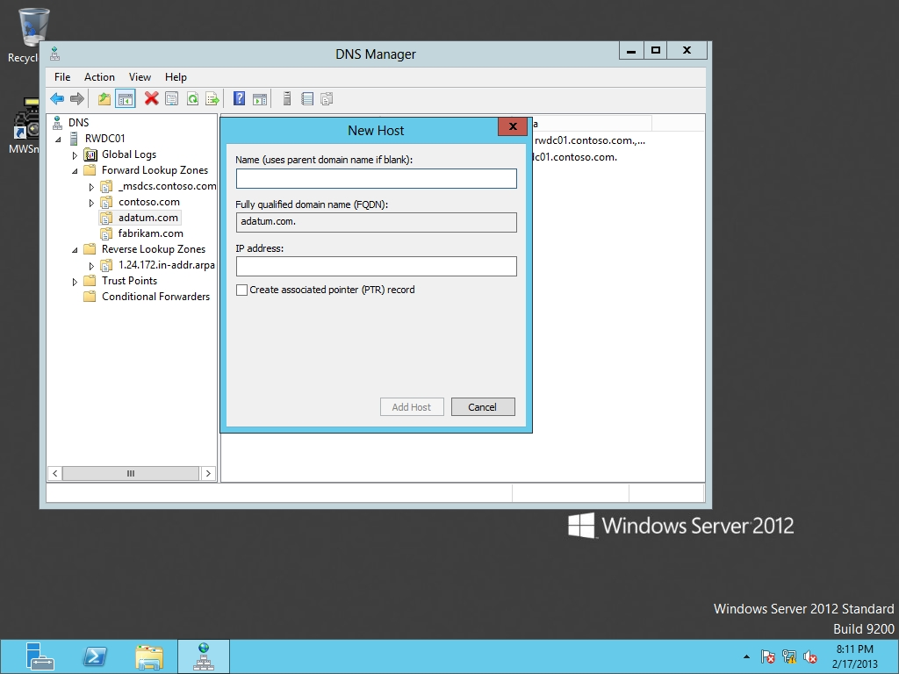

Figure 9-1

Creating a new host record

**7.** In the Name text box, type **PC1**. For the IP address text box, type **192.168.1.201**. click Add Host.

**8.** When the record has been created, click OK, then click Done.

**9.** Right-click adatum.com and click New Host (A or AAAA). In the Name text box, type **PC2**. For the IP address text box, type **192.168.1.202**. Select the *Create associated pointer (PTR) record*. Click Add Host. When the record has been created, click OK, then click Done.

**10.** Take a screen shot of the DNS Manager window by pressing Alt+Prt Scr and then paste it into your Lab09_worksheet file in the page provided by pressing Ctrl+V.

**11.** Expand the Reverse Lookup Zones and click 1.168.192.in-addr.arpa zone. Notice that the 192.168.1.202 record is there, but not the 192.168.1.201. You might need to refresh the zone if 192.168.1.202 has not yet appeared. To refresh the zone, press the F5 key.

|  |  |
| --- | --- |
| Question 4 | What records are kept in the reverse-lookup zones? |

**12.** Right-click 1.168.192.in-addr.arpa and click New Pointer (PTR). The New Resource Record dialog box opens as shown in Figure 9-2.

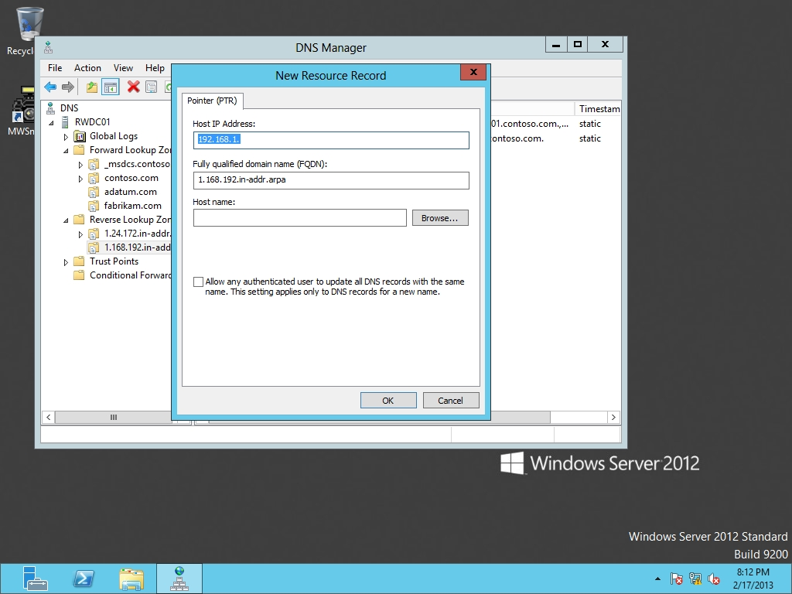

Figure 9-2

Creating a new PTR record

**13.** On the Host IP Address text box, change the text to **192.168.1.201**. In the Host name text box, type **PC1**. Click OK.

|  |  |
| --- | --- |
| Question 5 | How does the data for PC1 and PC2 differ? |

**14.** Double-click 192.168.1.201. Change the Host name from PC1 to **PC1.contoso.com.** (with a period at the end). Click OK.

|  |  |
| --- | --- |
| Question 6 | What does the period at the end signify? |

**15.** Take a screen shot of the DNS Manager window by pressing Alt+Prt Scr and then paste it into your Lab09_worksheet file in the page provided by pressing Ctrl+V.

**16.** Right-click adatum.com and click New Host (A or AAAA). In the Name text box, type **PC3**. For the IP address text box, type **192.168.1.203**. Select theCreate associated pointer (PTR) record. Click Add Host. When the record has been created, click OK, and then click Done.

**17.** Right-click adatum.com and click New Alias (CNAME). In the Alias name, type **www**. In the Fully qualified domain name (FQDN) for target host text box, type **PC3.adatum.com**.

|  |  |
| --- | --- |
| Question 7 | What is the fully qualified domain name? |

**18.** Click OK.

**19.** Right-click the Start button and click Command Prompt (Admin). The Administrator: Command Prompt opens.

**20.** To see the name PC1 resolved to its IP address, execute the following command:

nslookup PC3.adatum.com

|  |  |
| --- | --- |
| Question 8 | What address was returned? |

**21.** To see the IP resolution of 192.168.1.203 to its name, execute the following command:

nslookup 192.168.1.203

|  |  |
| --- | --- |
| Question 9 | What name was returned? |

**22.** To see the resolution of the alias [www.adatum.com](http://www.adatum.com) to its name and IP address, execute the following command:

nslookup www.adatum.com

|  |  |
| --- | --- |
| Question 10 | What name and IP address was returned? |

**23.** Right-click adatum.com and click New Mail Exchange (MX). In the Host or child domain text box, type **PC2**. In the Fully Qualified domain name (FQDN) of mail server, type **adatum.com**.

|  |  |
| --- | --- |
| Question 11 | What is the default Mail server priority? |

**24.** Click OK.

**25.** Right-click the PC1 Host (A) record under adatum.com, and click Properties.

|  |  |
| --- | --- |
| Question 12 | What fields are displayed? |

**26.** Click OK to close the Properties dialog box.

**27.** Open the View menu and click Advanced.

**28.** Right-click the PC1 Host (A) record and click Properties.

|  |  |
| --- | --- |
| Question 13 | What new field is now available with the Advanced view? |

**29.** Change the Time to live to **15** minutes. Click OK to close the Properties dialog box.

End of exercise. You can leave the windows open for the next exercise.

|  |  |
| --- | --- |
| Exercise 9.2 | Configuring Round Robin |
| Overview | By default, DNS Round Robin is enabled. Round robin operates by providing one DNS server IP address to a given query, then provides a different IP address for the next query, and so on, until a configured list of DNS server IP addresses runs out. The last query causes a loop-around to the first IP address and begins the sequence over again. In this exercise, you create two resource records to demonstate round robin switching between two separate DNS IP addresses |
| Completion time | 10 minutes |

**1.** On RWDC01, with DNS Manager console, create a host record for web.adatum.com that points to 192.168.1.205.

**2.** Create a second host record for web.adatum.com that points to 192.168.1.206.

**3.** At the command prompt, execute the following command:

nslookup web.adatum.com

|  |  |
| --- | --- |
| Question 14 | What addresses were returned? |

**4.** Re-execute the nslookup web.adatum.com command.

|  |  |
| --- | --- |
| Question 15 | What addresses were returned? |

**5.** Execute the following command:

ping web.adatum.com

Don’t worry that the ping fails; focus on the address that is returned.

**6.** Execute the ping web.adatum.com command, and then execute the command a third time. Observe that the return address toggles back and forth between 192.168.1.205 and 192.168.1.206, in effect, balancing the query load between two IP addresses.

End of exercise. You can leave the windows open for the next exercise.

|  |  |
| --- | --- |
| Exercise 9.3 | Configuring Zone Scavenging |
| Overview | With dynamic addresses, often resource records will be added to a DNS zone, and will remain there unless they are manually deleted or scavanged. During this exercise, you configure zone scavenging. |
| Completion time | 10 minutes |

**Mindset Question: If you want DNS zone scavenging, where do you have to enable zone scavenging?**

**1.** On RWDC01, with DNS Manager console, right-click the RWDC01 and click *Set Aging/Scavenging for all Zones*. The Server Aging/Scavenging Properties dialog box opens as shown in Figure 9-3.

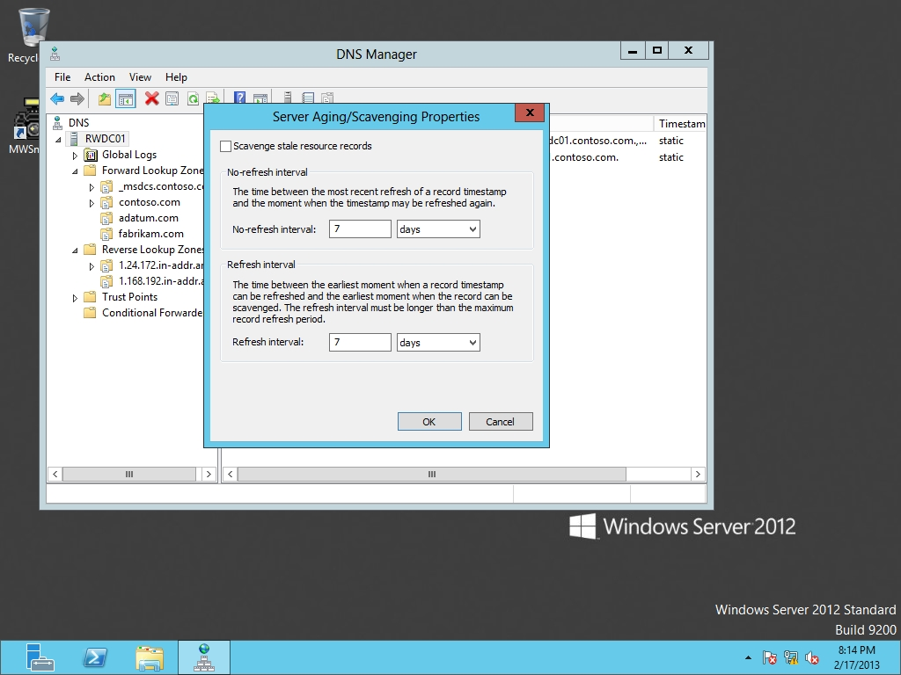

Figure 9-3

Configuring aging and scavenging settings

**2.** Click the *Scavenge stale resource records* option.

**3.** Click the OK button to close the *Server Aging/Scavenging Properties* dialog box.

**4.** Click to enable the *Apply these settings to the existing Active Directory-integrated zones* option. Click OK to close the Server Aging/Scavenging Confirmation dialog box.

**5.** Right-click the adatum.com zone and click Properties.

**6.** On the General tab, click the Aging button. The Zone Aging/Scavenging Properties dialog box opens.

**7.** Click to enable the *Scavenge stale resource records* option.

**8.** Take a screen shot of the DNS Manager window by pressing Alt+Prt Scr and then paste it into your Lab07_worksheet file in the page provided by pressing Ctrl+V.

**9.** Click the OK button to close the *Server Aging/Scavenging Properties* dialog box.

**10.** When you are prompted to apply aging/scavenging settings to the Standard Primary zone, click Yes.

**11.** Click the OK button to close the Properties dialog box.

End of exercise. You can leave the windows open for the next exercise.

|  |  |
| --- | --- |
| Exercise 9.4 | Troubleshooting DNS |
| Overview | In Exercise 9.2, you used nslookup to show name/IP resolution. However, during this exercise, you use nslookup in other ways to test DNS. You also use the DNS built-in tools to test DNS. |
| Completion time | 10 minutes |

**1.** On RWDC01, at the command prompt, execute the following command:

nslookup PC1.adatum.com

**2.** To start nslookup in interactive mode, execute the following command:

nslookup

**3.** To display the SOA record for adatum.com domain, execute the following commands:

set type=soa

adatum.com

**4.** To display the MX record for the adatum.com domain, execute the following commands:

set type=mx

adatum.com

**5.** Take a screen shot of the Command Prompt window by pressing Alt+Prt Scr and then paste it into your Lab09_worksheet file in the page provided by pressing Ctrl+V.

**6.** Close the Command Prompt.

**7.** On RWDC01, with DNS Manager console, right-click the RWDC01 and click Properties. The properties dialog box opens.

**8.** Click the Monitoring tab. Figure 9-4 shows the Monitoring tab.

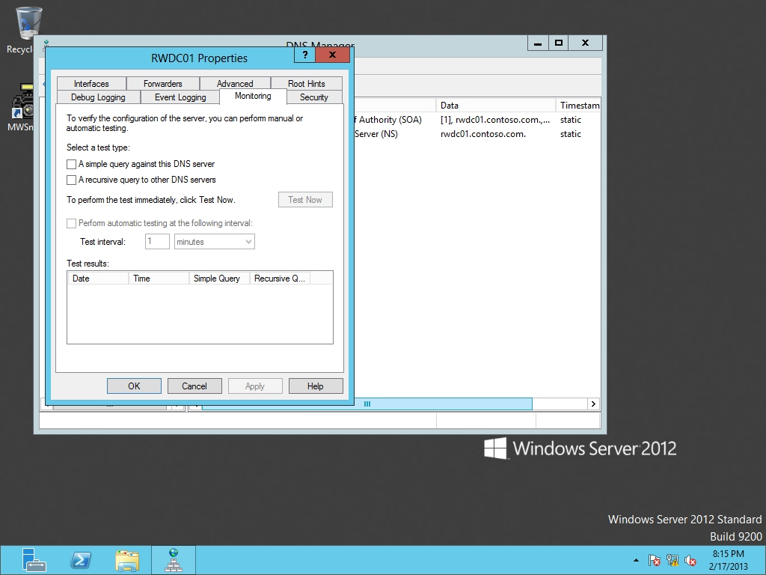

Figure 8-4

Monitoring the DNS server

**9.** Select to enable the following settings:

A simple query against this DNS server

A recursive query to other DNS servers

**10.** Click Test Now.

|  |  |
| --- | --- |
| Question 16 | Did either simple query or recursive query fail? If a failure did occur, why did it fail? |

**11.** Click OK to close RWDC01 Properties.

**12.** Close DNS Manager.

Lab REview Questions

|  |  |
| --- | --- |
| **Completion time** | **10 minutes** |

**1.** In Exercise 9.1,what is the most commonly used DNS resource record?

**2.** In Exercise 9.1, where is the default TTL stored?

**3.** In Exercise 9.1, where are PTR records stored?

**4.** In Exercise 9.1, what view do you need to be in to modify the TTL for an individual record?

**5.** In Exercise 9.2, how did you enable round robin?

**6.** In Exercise 9.3, to enable zone scavenging, what two places did you have to configure?

**7.** In Exercise 9.4, what tool is used to test DNS queries?

|  |  |
| --- | --- |
| Lab Challenge | Using the DNSCMD Command to Manage Resource Records |
| Overview | To complete this challenge, you must demonstrate how to use the DNSCMD command. |
| Completion time | 5 minutes |

You need to configure a few scripts that will create DNS zones. What commands would you use to perform the following on RWDC01.contoso.com for the contoso.com domain:

Add a host record for Test01 with an IPv4 address of 192.168.1.221 on the RWDC01 server.

Delete the Test01 record that you just created in the previous step.

End of lab. You can log off or start a different lab. If you want to restart this lab, you’ll need to click the End Lab button in order for the lab to be reset.